SCHOOL OF ENGINEERING AND TECHNOLOGY

Department: Computer Engineering

Specialty: Software Engineering/Graphics and Web Design Topic: EMPLOYEE MANAGEMENT SYSTEM.

Name of student:

ALI-NDI NESINYU TATAH

ENONCHONG HOPE AHONE

KWA ADELLA MUNSHI

NAME OF SUPERVISOR: MR KAH KISSINGER

TABLE OF CONTENT.

List of Figures …………………………………………………………………………………..

List of Tables …………………………………………………………………………………..

List of Abbreviations ……………………………………………………………………………

Chapter 1: General Introduction

1.1 Introduction ………………………………………………………………………………………………………………………

1.2 Problem statement…………………………………………………………………………………………………………….

1.3 Aim and Objectives…………………………………………………………………………………………………………….

1.4 Significance of study…………………………………………………………………………………………………………..

1.5 Scope of project ………………………………………………………………………………………………………………..

Chapter 2: Literature Review

2.1 Introduction, Overview of Topic, scope, purpose………………………………………………………………

2.2 Existing Literature. (Describing different existing system, Application, advantages and limitations) ……………………………………………………………………………………………………………………………..

Chapter 3: Methodology

3.1 Introduction (Overview of research methodologies) ……………………………………………………………..

3.2 Methodology Approach ………………………………………………………………………………………………………

3.2.1 Presentation of Software Methodologies / System Methodologies ………………………….

3.2.2 Adopted Methodology, with reasons. ………………………………………………………………………..

3.2.3 Software Development Life cycle / System Design stages ……………………………………

3.3 System Requirement

3.3.1 Physical requirements. Tools and Technologies used …………………………………………..

3.3.2 Design and Architectural requirement / Block Diagrams ………………………………………

Chapter 4: Presentation and Discursion of Results (Analysis and Design Diagrams)

4.1 Design and Analysis ………………………………………………………………………………………………..

4.1.1 Flow chart ………………………………………………………..……………………………………………………..

4.1.2 Use Case diagrams ……………………………………………………………………………………………………

4.1.3 Class Diagram………………………………………….…………………………………………………………………

4.1.4 Sequence Diagrams …………………………………………………………………………………………………….

4.1.5 Activity Diagrams ………………………………..………………………………………………………………………

4.1.6 E-R Diagram

4.2 Results/Simulations of working system ………………………………………………………………………………..

Chapter 5: Summary, Recommendations and Conclusion................................................................

5.1 Applications/ relevance of project …………………………………………………………………………………………

5.2 Challenges and Limitations …………………………………………………………………………………………………...

***List of figures.***

1. *Figure 01………………………………………..…………………………………………… Waterfall model*
2. *Figure 02…………………………………….……………………………………. Agile methodology diagram*
3. *Figure 03……………………………………………..…………………. Scrum methodology diagram*
4. *Figure 04……………………………………………………………………. DevOps methodology*
5. *Figure 05…………………………………………………………………..…. Database interaction workflow*
6. *Figure 06……………………………………………………… Designed Employee management pages*
7. *Figure 07…………………………………………..……………………………………. Flowchart*
8. *Figure 08………………………………………………………….………………. Use case diagram*
9. *Figure 09…………………………………………………….………………………………….Class diagram*
10. *Figure 10…………………………………………………………………….……. Login sequence diagram*
11. *Figure 11………………………….………………………………………………………. Browse sequence diagram*
12. *Figure 12…………………………………………..………………………………. Search info sequence diagram*
13. *Figure 13…………………………………………………………….upload content sequence diagram*
14. *Figure 14………………………………………………………………………..……………. Activity diagram*

**GLOSSARY**

**PHP (Hypertext pre-processor):** General purpose scripting language that is used for web development and is embedded into HTML.

**UML (Unified modelling language):** standardized general-purpose modelling language in the field of object-oriented software engineering

**WWW (World Wide Web):** a system of interlinked hypertext documents accessed via the

Internet.

**HTTP (Hypertext transfer protocol):** Set of rules for transferring files on World Wide Web.

**MySQL (My structured Query language):** relational database management system that runs as a server providing multi-user access to number of databases.

**HS (Human Resource)**

**EMS (Employee Management System)**

**CHAPTER ONE**

**GENERAL INTRODUCTION**

Employee Management System Project is designed to keep track of employee information in any company. It stores data such as their employees' personal information leave details and salary details.

The employee management system project gives managers a better idea of their employees and helps them plan and manage their work hours to cut costs and boost productivity. It gives appropriate directions and supervisions for employees. It also secures and manages information that are important to the employees including personal and work-related information.

Employee management system is developed to manage the data and information of an employee in a company. It is developed to override the problems prevailing in the practicing manual system.

The purpose of the Employee Management System is to centralize and digitize employee-related data and processes, eliminating manual and paper-based workflows. By implementing this system, we aim to improve efficiency, accuracy, and productivity in managing employee information, attendance, leave management, performance evaluation, and other HR functions.

PROBEM STATEMENT.

The problem statement for the Employee Management System (EMS) involves developing a comprehensive software solution. The current manual and paper-based employee management processes within our organization present several challenges and inefficiencies. These issues hinder our ability to effectively manage employee information, track attendance, handle leave requests, conduct performance evaluations, and facilitate seamless communication among employees, managers, and human resource administrators.

The system must address challenges such as data security, scalability, integration with existing systems, user adoption, customization, and ongoing maintenance while providing a user-friendly interface and ensuring regulatory compliance.

AIM OF PROJECT.

1. **Data Organization:** Centralize employee information for easy access, updating, and retrieval, reducing manual paperwork and administrative overhead.
2. **Enhanced Decision-Making:** Provide managers with timely access to relevant employee information for informed decision-making regarding resource allocation, performance management, and workforce planning
3. **User-Friendly Interface:** Develop an intuitive and user-friendly interface that encourages adoption by employees and reduces the learning curve for administrators and managers.
4. **Improved Efficiency:** The primary aim of this project is to enhance the efficiency of employee management processes within the organization. By automating manual tasks, streamlining workflows, and centralizing employee data, the system aims to reduce administrative overhead and improve overall process efficiency.
5. **Accuracy and Compliance:** Ensure accurate recording of employee data and adherence to regulatory requirements such as data privacy laws and labor regulations.
6. **Compliance and Data Security**: The project aims to ensure compliance with data privacy regulations and employment laws. By implementing robust security measures, access controls, and data encryption, the system aims to safeguard employee data, protect privacy, and maintain compliance with relevant regulations.
7. **Integration:** Seamlessly integrate with existing systems such as payroll software, time tracking tools, and third-party APIs to ensure data consistency and interoperability.

**OBJECTIVES OF THE PROJECT.**

1. To consolidate all employee-related information into a centralized database, making it easily accessible and ensuring data integrity in order to streamline Human Resource processes.
2. Onboarding and off boarding: To streamline the onboarding process for all employees and facilitate the off boarding process.
3. To accurately track employee attendance, manage leave requests, and streamline payroll processing. In order to ensure fair and accurate compensation for employees, reduces payroll errors, and improves workforce planning.
4. To set performance goals, conduct performance evaluations, and provide feedback to employee. Which equally Promotes employee development, enhances accountability, and aligns individual performance with organizational goals.
5. To facilitate communication and collaboration among employees, managers, and Human Resource personnel in the organization.
6. To empower employees to access and manage their own information, submit leave requests, and participate in training programs.
7. To provide reporting and analytics capabilities for monitoring Human Resource metrics, tracking employee performance, and identifying trends. Which Enables data-driven decision-making, supports strategic planning, and fosters continuous improvement.
8. To design the Employee Management System to be scalable and adaptable to accommodate organizational growth and evolving needs.
9. To further integrate the Employee Management System with other relevant systems such as payroll software, time tracking tools, and performance management platforms.

**SIGNIFICANCE OF THIS SCOPE.**

The significance of this project (Employee Management System) lies in its potential to bring numerous benefits and improvements to the organization. Such as:

1. Enhanced Efficiency and Productivity: By automating manual tasks, streamlining processes, and centralizing employee data, the system can significantly improve the
2. on more strategic and value-added activities, leading to increased overall productivity within the organization.
3. Improved Data Accuracy and Integrity: The study addresses the challenge of maintaining accurate and reliable employee data. By implementing standardized data entry processes, validation mechanisms, and secure storage, the system ensures the integrity and accuracy of employee information, reducing errors, inconsistencies, and data duplication.
4. Streamlined Workflows and Reduced Administrative Overhead: The study aims to streamline various HR processes such as onboarding, off boarding, attendance tracking, leave management, and performance evaluations. Automating these processes eliminates manual effort, reduces paperwork, and minimizes administrative overhead. This results in time and cost savings for the organization.
5. Enhanced Decision-Making with Data Insights: The system's reporting and analytics capabilities provide valuable insights into HR metrics, performance evaluations, and employee trends. This empowers managers and HR personnel to make data-driven decisions, identify areas for improvement, and align HR strategies with organizational goals.
6. Improved Communication and Collaboration: The study focuses on enhancing communication and collaboration among employees, managers, and HR administrators. By providing integrated communication tools and a centralized platform for sharing information and announcements, the system fosters effective communication, knowledge sharing, and collaboration, resulting in improved teamwork and employee engagement.
7. Enhanced Employee Experience and Engagement: The system's self-service capabilities, such as employee self-access to information, leave requests, and training programs, empower employees and enhance their experience. This leads to increased employee satisfaction, engagement, and retention, contributing to a positive work environment and a more motivated workforce.
8. Compliance with Data Privacy and Employment Regulations: The study addresses the importance of compliance with data privacy regulations and employment laws. By implementing robust security measures, access controls, and data encryption, the system ensures the confidentiality, integrity, and protection of employee data, mitigating the risk of legal and regulatory non-compliance.

**SCOPE OF PROJECT.**

The scope of a project refers to the extent to which the application will be developed. This is a mobile application that will be simulated with Figma and developed with time.

CHAPTER TWO

**DESCRIPTION:** This application focus on creating a software solution for business and organizations. The Employee Management System (EMS) is a software solution designed to streamline and automate various Human Resource processes within a small-scale enterprise. The system aims to centralize employee data, simplify administrative tasks, and improve overall efficiency in managing personnel-related activities.

The Employee Management System is a comprehensive software solution designed to streamline and automate various aspects of employee management within an organization. It encompasses a range of functionalities, including employee information management, attendance tracking, leave management, performance evaluation, employee onboarding, and communication tools. The system aims to enhance organizational efficiency, improve employee engagement, and simplify administrative tasks related to human resource management.

**Scope:**   
The Employee Management System covers the entire employee lifecycle, starting from the recruitment and onboarding process to ongoing performance management and off boarding. It incorporates features to store and manage employee information, such as personal details, job history, qualifications, and skills. The system facilitates accurate tracking of employee attendance, leaves, and time-off requests. It also provides a platform for performance evaluations, goal setting, and feedback exchange between employees and managers. In addition, the system may include communication tools, such as messaging or notification systems, to facilitate effective communication within the organization.

**Purpose:**   
The purpose of the Employee Management System is to centralize and streamline employee-related processes, ensuring efficient management and utilization of human resources. The system aims to achieve the objectives as mentioned in chapter 1.

**Existing Systems.**

CHAPTER THREE

METHODOLOGY

INTRODUCTION.

A methodology refers to a systematic and structured approach used to conduct research, solve problems, or achieve specific objectives in a particular field of study. It outlines the principles, procedures, tools, and techniques that guide the research or problem-solving process. Methodologies provide a framework to ensure that research or problem-solving activities are conducted in a logical, organized, and rigorous manner.

**Over View Of Research Methodologies**

1. Content analysis is a research method used to systematically analyze and interpret the content of various forms of communication, such as text, audio, video, images, or social media posts. It involves a systematic and objective approach to studying the characteristics, themes, patterns, and meanings present in the collected content.

Here, data about the employee management system was gathered from the systematic approach of studying the characteristics of the existing system such as the eSkooly employee management system.

1. **Action Research:** in this methodology there was collaboration between our team and practitioners or stakeholders and managers to address real-world problems or improve practice in a specific context. Action research typically involves cycles of planning, action, observation, and reflection.
2. **Survey Research:** Surveys are used to collect data from a large sample of individuals about their attitudes, opinions, behaviors, or characteristics. Surveys can be conducted through various methods, including online questionnaires, telephone interviews, or face-to-face interviews.
3. **Qualitative Research:** This focuses on understanding the underlying reasons, motivations, and opinions behind a particular phenomenon. It involves collecting and analyzing non-numerical data such as interviews, observations, or textual analysis.

**Presentation of Software Methodologies / System Methodologies**

Methodologies provide guidelines, principles, and techniques to manage the development process. They include:

1. **Water fall model.** The waterfall model is the first model in software development history. It is also referred to as the (Linear sequential life cycle model) this model is simple to understand and use. In the waterfall model, each phase is completed before moving to the next phase. The waterfall model is the first and earliest approach used in SDLC for the development of software products in this model that do not overlap.

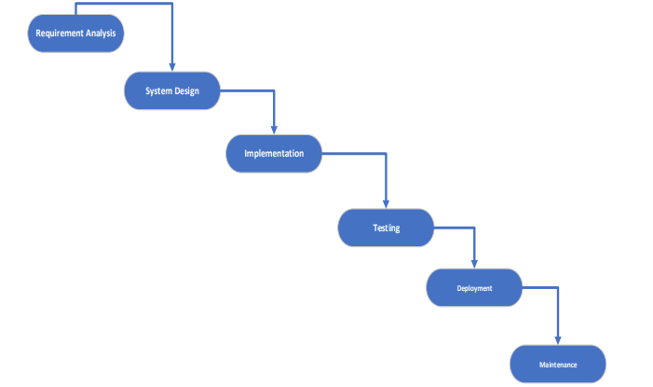

*Figure 01: Waterfall Model.*

1. **Agile Methodology:** it is a flexible iterative approach to software development with emphasis on rapid prototyping and continues delivery.



*Fig 1.0 Agile methodology*

1. **Scrum:** it is a popular agile methodology that emphasizes team work, iterative development and flexible adaptive approach in planning and management of software processes.

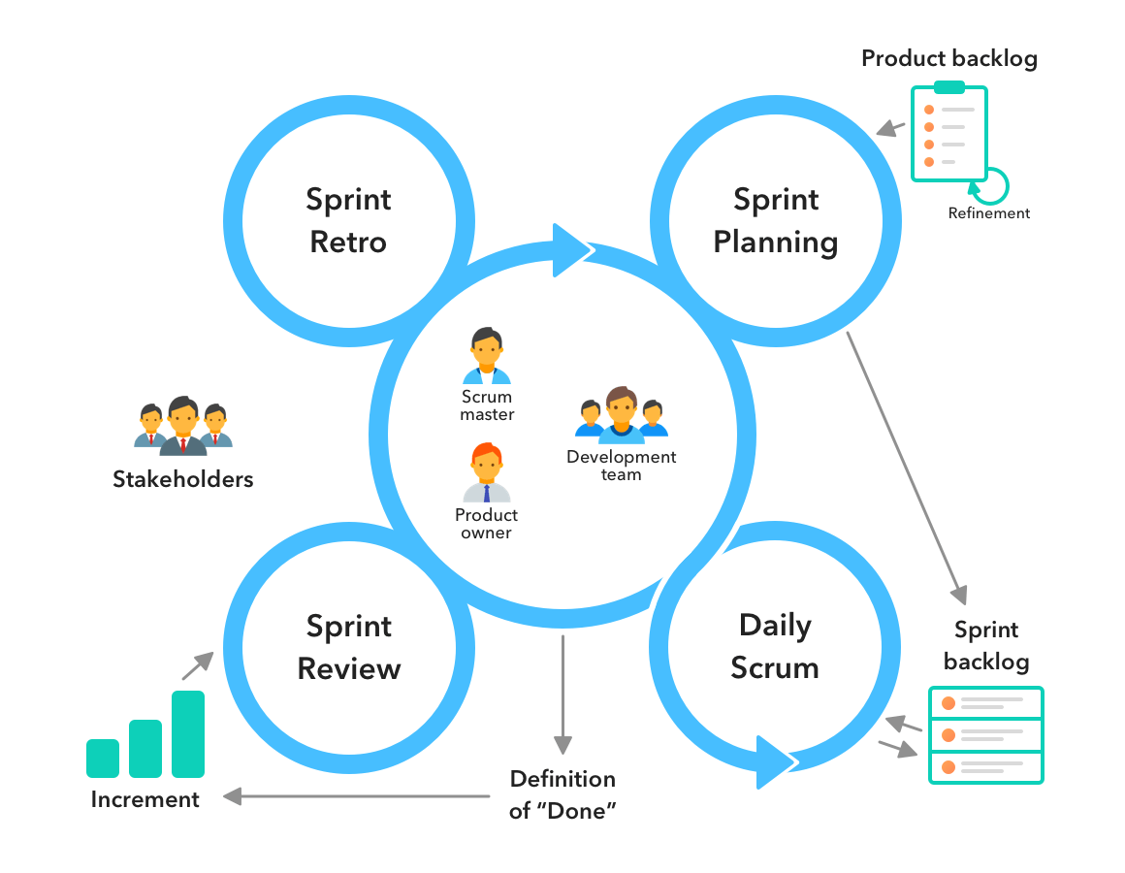

*Fig 03: Scrum Methodology*

1. **DevOps Methodology.** This is a set of practices that aims to improve collaboration and communication between development teams and operation teams, with emphasis on automating the software delivery process.

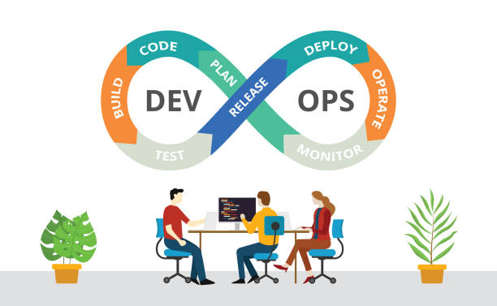

*Figure 04. DevOps Methodology.*

**Adopted methodology: WATER FALL**

Advantages of Waterfall models.

1. Clear Structure: The Waterfall methodology follows a sequential and structured approach with distinct phases, such as requirements gathering, design, implementation, testing, and maintenance. This clear structure provides a well-defined roadmap for the development process.
2. Comprehensive Documentation: Waterfall methodology encourages thorough documentation at each phase. This documentation ensures that requirements, design, and implementation details are well-documented and can serve as a reference for future maintenance or updates.
3. Predictability: The linear and sequential nature of the Waterfall methodology allows for better predictability in terms of timelines, milestones, and deliverables. Project managers and stakeholders can have a clear understanding of the project's progress and can plan accordingly.
4. Early Identification of Issues: Each phase in the Waterfall methodology typically includes a review or verification process before moving on to the next phase. This helps in early identification of issues, allowing for timely corrective actions.
5. Suitable for Stable Requirements: The Waterfall methodology is well-suited for projects with stable and well-defined requirements. It works best when the requirements are clear, fixed, and unlikely to change significantly during the development process.
6. Resource Allocation: The Waterfall methodology allows for efficient allocation of resources as each phase is completed before moving on to the next. This can help in better resource planning and allocation, ensuring that resources are utilized optimally.
7. Customer Involvement: While Waterfall is often criticized for limited customer involvement, it can be advantageous in certain scenarios where customers prefer a more hands-off approach. Some stakeholders may appreciate having a clear timeline and deliverables without needing to be actively involved in the day-to-day development process.

**Also;**

1. Simple and Easy to understand.
2. Clearly and defined stages
3. Easy to arrange tasks.
4. Process and results are well documented.
5. Works well when the project is small.
6. Easy to manage due to the rigidity of the model.

**SYSTEM DESIGN METHODOLOGY**

1. Project Overview:
   * Purpose: The purpose of the project is to develop an employee management system that will streamline HR processes, improve employee data management, and enhance overall efficiency.
   * Goals: The primary goals of the project are to create a centralized database for employee information, automate attendance tracking and leave management, facilitate performance evaluation, and provide reporting capabilities.
   * Objectives: The objectives include developing a user-friendly interface, ensuring data security and privacy, and delivering the project within the allocated budget and timeline.
   * Stakeholders: The key stakeholders include HR department personnel, management team members, IT staff, and employees who will use the system.
2. **Requirement Analysis**

* Introduction:
  1. The requirement analysis phase aims to gather and analyze the functional and non-functional requirements of the employee management system.
  2. The analysis helps in understanding the needs and expectations of stakeholders and ensures that the system meets those requirements.

**Requirements gathering from stake-holders.**

* User-friendly interface: Intuitive design to ensure ease of use for administrators, managers, and employees.
* Security: Robust security measures to protect sensitive employee data, including encryption, role-based access control, and compliance with data protection regulations.
* Scalability: Capability to handle growing numbers of employees and adapt to changing organizational needs over time.
* Integration: Seamless integration with existing systems such as payroll, HRIS (Human Resources Information System), time tracking, and attendance management.
* Reporting and analytics: Comprehensive reporting features to track employee performance, attendance, leave balances, and other relevant metrics.
* Mobile accessibility: Support for mobile devices to allow access to the system anytime, anywhere.
* Notifications and alerts: Automated notifications for important events such as upcoming deadlines, performance reviews, or policy updates.
* Support and maintenance: Ongoing technical support, updates, and maintenance to ensure the system operates smoothly and efficiently.

**Requirements from Human Resource personnel, managers, and employees**

* **Human Resource Personnel***.*
* Efficient HR Processes: Expect streamlined processes for recruitment, onboarding, performance management, and other HR activities.
* Centralized Employee Database: Access to a centralized database with accurate and up-to-date employee information.
* Attendance and Leave Management: Tools for tracking attendance, managing leave requests, and generating relevant reports.
* Performance Analytics: Features for evaluating employee performance, generating reports, and identifying areas for improvement.
* Compliance and Security: Ensure the system complies with legal requirements and industry standards, and provides robust security for sensitive HR data.
* **Managers.**
* Employee Performance Tracking: Tools to monitor and assess the performance of their team members.
* Approval Workflows: Streamlined processes for approving leave requests, performance assessments, and other managerial tasks.
* Communication and Collaboration: Integration of communication tools and collaborative features for better team engagement.
* Data-driven Decision-Making: Access to analytics and reports to make informed decisions related to team performance and resource allocation.
* **Employees.**
* Self-Service Portals: Ability to view and update personal information, request time off, and access relevant HR documents.
* Performance Feedback: Access to performance reviews, goal-setting features, and opportunities for self-assessment.
* Training and Development: Features for tracking training progress, accessing learning resources, and planning career development.
* Communication Channels: Integration with communication tools for receiving company updates, announcements, and feedback.
* User-Friendly Interface: Intuitive and easy-to-use interfaces that simplify tasks like submitting timesheets, viewing pay stubs, and participating in performance evaluations**.**

1. **FUNCTIONAL REQUIREMENTS.**
2. User Authentication:

* Users must register and authenticate to access and contribute to the platform.
* Two-factor authentication or similar security measures should be implemented.
* Implement a secure login mechanism with role-based access control to ensure that only authorized personnel can access the system and perform specific actions.

1. Employee Profile Management:

* Allow HR administrators to create, update, and maintain employee profiles with relevant information such as personal details, contact information, employment history, and qualifications.

1. Onboarding Workflow:

* Provide a step-by-step onboarding workflow

That guides HR personnel through the necessary tasks and documentation required when hiring new employees, such as collecting personal informatioG n, verifying credentials and assigning jobs and roles.88888888

1. Off boarding Workflow:

* Define a process to manage employee departures effectively, including tasks like exit interviews, asset return, and system access, and system access revocation.

1. Attendance Tracking:

Develop a mechanism to record employee attendance, including options for manual entry or integration with a time tracking system. This should include tracking regular work hours, overtime, and absences.

1. Leave Management: Enable employees to request different types of leaves (e.g., vacation, sick leave) through the system, and provide HR personnel with the ability to review, approve, and track leave requests. The system should also maintain accurate leave balances for each employee.
2. Payroll Integration: Integrate the employee management system with a payroll software solution to automate the calculation of salaries, deductions, and tax withholdings based on attendance records, leave data, and other relevant factors.
3. Performance Evaluation: Implement a performance evaluation module that allows managers to set performance goals, conduct periodic evaluations, and provide feedback to employees. The system should track evaluation history and support performance improvement plans.
4. Training and Development: Enable employees to view available training programs, enroll in courses, and track their progress. HR personnel should have the ability to manage training schedules, track participation, and generate reports on training activities.
5. Communication Tools: Provide features such as internal messaging, announcements, and notifications to foster communication and collaboration among employees, managers, and HR administrators within the system.
6. Reporting and Analytics: Generate standard and custom reports related to employee data, attendance, leave balances, performance metrics, and training activities. The system should also support data visualization and analytics to identify trends and patterns.
7. Document Management: Allow for secure storage and management of employee-related documents, such as contracts, certifications, performance appraisals, and disciplinary records. Implement version control and access controls to ensure data integrity and confidentiality.
8. Document Templates: Provide pre-defined templates for common HR documents such as offer letters, employment contracts, and performance evaluation forms. Users should be able to generate these documents with relevant employee data.
9. Workflow Automation: Automate repetitive HR tasks and workflows, such as generating reports, sending reminders for performance evaluations or contract renewals, and triggering notifications for upcoming training deadlines.
10. Mobile Accessibility: Develop a mobile-friendly interface or a dedicated mobile app to allow employees and managers to access the system, submit requests, and perform tasks on the go.

**c) NON-FUNCTIONAL REQUIRMENETS.**

1. Security: Ensure the system has robust security measures in place to protect employee data, including authentication mechanisms, data encryption, access controls, and secure transmission of information.
2. Scalability: Design the system to handle a growing number of employees and increasing data volume without significant performance degradation. It should be able to scale horizontally or vertically as needed.
3. Performance: The system should be responsive and perform efficiently, enabling quick data retrieval, minimal latency, and smooth user interactions even during peak usage periods.
4. Reliability: Ensure high system availability, minimizing downtime and interruptions. Implement backup and disaster recovery mechanisms to safeguard data.
5. Usability: The system should have a user-friendly interface with intuitive navigation, clear labels, and consistent design. Consider accessibility features to accommodate users with disabilities.
6. Compatibility: Ensure compatibility with different web browsers, operating systems, and devices to provide a consistent experience for users accessing the system from various platforms.
7. Integration: The system should support integration with other relevant systems, such as payroll software, time tracking tools, or performance management platforms, enabling seamless data flow and eliminating duplicate data entry.
8. Data Integrity: Implement data validation mechanisms to ensure the accuracy, completeness, and consistency of employee data. Employ data backup and restoration procedures to prevent data loss.
9. Compliance: Adhere to relevant laws, regulations, and industry standards pertaining to data privacy, confidentiality, and employment practices, such as GDPR or local labor laws.
10. Performance Monitoring: Set up monitoring tools to track system performance, identify bottlenecks, and proactively address issues. This includes monitoring server resource utilization, database performance, and response times.
11. System Maintenance: Define regular maintenance procedures, including software updates, bug fixes, and database maintenance, to keep the system running smoothly and securely.
12. Training and Support: Provide comprehensive user documentation and training resources to help users understand the system's features and functionalities. Offer technical support channels to address user inquiries and issues.
13. Data Backup and Recovery: Implement regular data backup procedures, both onsite and offsite, to ensure data resilience and the ability to restore data in case of system failures or disasters.
14. Performance and Load Testing: Conduct performance and load testing to assess the system's capacity, identify performance bottlenecks, and optimize system performance to meet expected user load.
15. System Logging and Auditing: Implement logging and auditing mechanisms to track system activities, user actions, and changes to employee data. This supports troubleshooting, accountability, and compliance requirements.
16. **Design**

# **DESIGNER’S INTERPRETATION OF THE PROBLEM**

The manager and stakeholders’ would like to have **remote access** to the employee system application. This means that it has to have a web-based interface but should also provide an interface for a mobile device. The data will be stored in a database.

# **HIGH LEVEL CONSTITUENTS PARTS**

The system will consist of two constituents. That is Software management and database management. Database management will be managed by the manager/administrator. Here are features or characteristics of these two constituents:

**DATABASE AND SOFTWARE MANAGEMENT:**

* Will be accessible on different devices or platforms.
* Will be to add or delete from database.
* Will enable editing of data on the database.
* Will enable retrieval of data from the database.
* Will enable searching through the data and make reports from his findings.Below is depiction of how the users will interact with the system:

Retrieve

Insert

Update

Delete

Application

program

Database System:

•

Database

•

DBMS

*Figure 05: database interaction flow*

* **Onboarding And Log-in Pages**



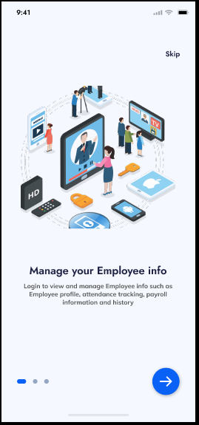

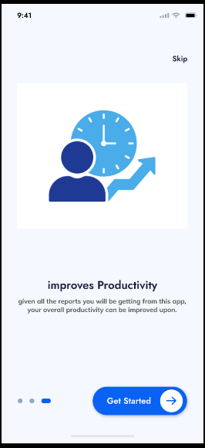

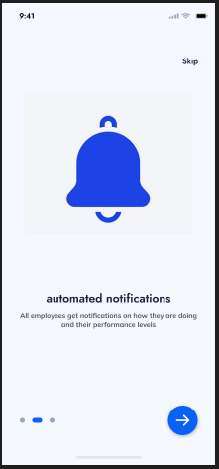

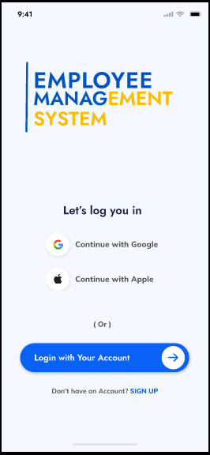

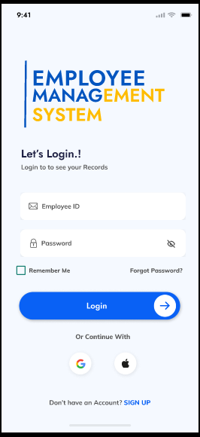

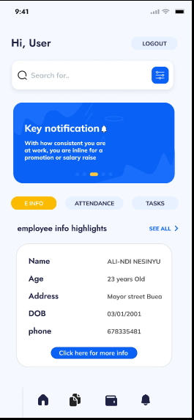

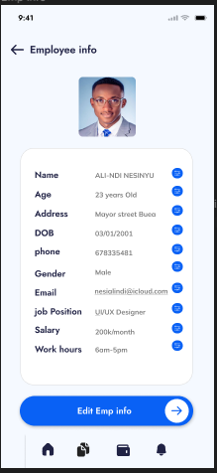

**Landing Page**

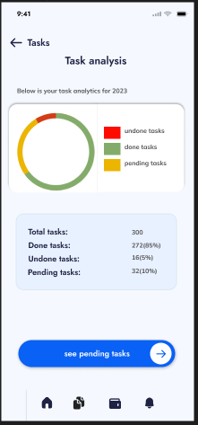

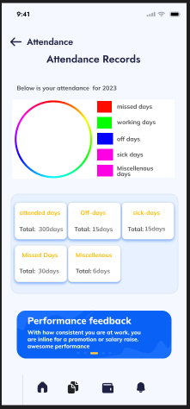

1. **Implementation.**

# TECHNOLOGY

Since its web-based software, we decided to use:

* Apache (webserver)
* PHP
* MySQL WHY??

This because they are:

* (Web slave/advantages of apache, 2011) Flexible.
* Its open source so it’s cheap.
* It is efficient and easily managed.

We shall be using the following software.

**APACHE:**

Free available web server. This allows MySQL and PHP to run on it.

**PHP:**

Hypertext Pre-processor. It is a widely used general- purpose scripting language that is especially suited for web development and can be embedded into HTML. Above all its free that is open source.

**MySQL:**

It’s a relational database management system (RDBMS) that runs as a server providing multi- user access to a number of databases.

**PHPMyAdmin:**

It is open source software written in PHP with the intention of handling the administration of MySQL over the World Wide Web. It also supports wide range of MySQL operations.

**JAVASCRIPT:**

It is a scripting language that used to make web pages interactive.

**HTTP:**

Hyper Transfer Protocol (HTTP) is a set of rules for transferring files (text, graphic, images, sound, video and other multimedia files) on the World Wide Web (WWW).

1. **TESTING**

**SYSTEM TESTING:**

**WHITE BOX TESTING**

This is a verification technique for software developers use to examine if their code works as expected. We will use this method to detect errors during software development. White box which is also known as clear box helps in optimizing of my code. Using the aspect of unit testing we shall be go through each and every line of code. This makes it easy for us to remove extra lines of code that can bring about hidden errors.

**USUABILITY TESTING**

This is a technique used to evaluate the quality of the software. This is where random users are used to test the product using different data and their response to the system is put into consideration.

**BLACK BOX TESTING**:

It is also known as functional testing. This technique is used to test the complete system. Black box testing ignores all the whole system components and focuses only on the outputs generated for a particular input. Different data will be used for each function to check if the right output is gotten. This is to check the behavior of the system as per different input data.

# CONCLUSION

Employee management system (EMS) is going to be implemented using PHP, MySQL, Apache and PHPMyAdmin which are all open source applications. They are all a solution to web based system.

WHY??

After examining all the possible solutions, we decided on a web based system to address this problem.

1. Deployment.

We intend to:

1. Preparing for Deployment:
   * Identify the deployment environment: Determine the hardware, software, and infrastructure required for hosting the EMS, such as servers, databases, and networking components.
   * Set up the deployment environment: Install and configure the necessary servers, databases, web servers, and any other required software or dependencies.
   * Ensure compatibility: Verify that the deployment environment meets the EMS's compatibility requirements, including supported operating systems, software versions, and network configurations.
2. Build and Configuration Management:
   * Build the application: Compile the EMS source code and package it into a deployable format, such as an executable file, a container image, or a deployable archive.
   * Version control: Ensure that the EMS code and any configuration files are under version control to track changes and facilitate rollback if necessary.
   * Configuration management: Configure the EMS settings specific to the deployment environment, such as database connection strings, API keys, and server URLs.
3. Testing and Quality Assurance:
   * Perform testing: Conduct thorough testing of the EMS in the deployment environment to ensure proper functionality, performance, and compatibility.
   * Regression testing: Verify that the deployment process has not introduced any new bugs or issues compared to the tested and approved system version.
   * User acceptance testing (UAT): Collaborate with stakeholders and end users to validate the EMS's functionality and usability in the deployment environment.
4. Data Migration:
   * Plan data migration: Develop a strategy to migrate existing employee data from the old system or sources to the EMS.
   * Data extraction: Extract employee data from the existing sources while ensuring data integrity and accuracy.
   * Data transformation: Convert and format the data to match the structure and requirements of the EMS.
   * Data loading: Import the transformed data into the EMS's database, ensuring proper mapping and validation.
5. Deployment Execution:
   * Prepare a deployment plan: Outline the steps and sequence for deploying the EMS, including any necessary downtime or maintenance windows.
   * Backup and rollback plan: Create backups of the existing system and data to facilitate a rollback in case of any unforeseen issues or failures during deployment.
   * Deploy the application: Follow the deployment plan to install and configure the EMS in the target environment.
   * Verify deployment: Perform post-deployment checks to ensure that the EMS is functioning correctly and all components are properly connected.
6. Training and Documentation:
   * Conduct user training: Provide training sessions to stakeholders and end users on how to use the EMS effectively.
   * Update system documentation: Update user manuals, system documentation, and any related material to reflect the changes and features of the deployed EMS.
7. Post-deployment Activities:
   * Monitor system performance: Continuously monitor the EMS's performance, resource utilization, and user feedback to identify and address any issues or bottlenecks.
   * Bug fixes and updates: Address any post-deployment issues, bugs, or feature requests through timely bug fixes and software updates.
   * Continuous improvement: Seek feedback from users and stakeholders to identify areas for improvement and plan for future enhancements or updates.
8. **Maintenance**

We intend to;

1. Establishing a Maintenance Plan:
   * Define maintenance objectives: Clearly define the goals and objectives of the maintenance activities for the EMS, such as ensuring system stability, addressing bugs and issues, and implementing enhancements.
   * Determine maintenance schedule: Establish a regular maintenance schedule that includes routine tasks, such as backups, security updates, and system checks.
   * Allocate resources: Assign dedicated resources, such as personnel, time, and budget, to perform maintenance tasks effectively.
2. Bug and Issue Tracking:
   * Set up a bug tracking system: Implement a system or software for tracking and managing reported bugs and issues.
   * Prioritize and categorize issues: Classify reported issues based on their impact and urgency to prioritize the resolution process.
   * Investigate and diagnose: Analyze reported bugs and issues to identify the root causes and potential solutions.
   * Develop and implement fixes: Develop patches or updates to address identified bugs and issues, and deploy them in a controlled manner.
3. Performance Monitoring and Optimization:
   * Monitor system performance: Continuously monitor the EMS's performance to identify any performance bottlenecks or issues.
   * Collect and analyze data: Gather performance metrics, such as response times, resource utilization, and system logs, to analyze and identify areas for improvement.
   * Optimize system performance: Implement performance optimization techniques, such as caching, indexing, and query optimization, to enhance the EMS's speed and efficiency.
4. Security Maintenance:
   * Keep up with security updates: Stay informed about the latest security vulnerabilities and apply security patches and updates to the EMS software, infrastructure, and dependencies.
   * Conduct security audits: Regularly assess the EMS's security posture through audits and vulnerability assessments to identify and address potential security risks.
   * Implement security best practices: Enforce security measures, such as strong password policies, user access controls, and encryption, to protect sensitive data and prevent unauthorized access.
5. Backup and Disaster Recovery:
   * Establish backup procedures: Set up regular backup routines for critical data and system configurations to ensure data integrity and facilitate disaster recovery.
   * Test backup and recovery processes: Periodically test the backup and recovery procedures to ensure that backups are accessible and can be successfully restored in case of data loss or system failure.
   * Document disaster recovery plans: Develop and maintain a disaster recovery plan that outlines the steps and procedures for recovering the EMS in the event of a major incident or system failure.
6. User Support and Training:
   * Provide user support: Establish a support system to address user inquiries, issues, and requests related to the EMS.
   * Maintain user documentation: Update user manuals, FAQs, and knowledge bases to reflect any changes or enhancements to the EMS.
   * Conduct training sessions: Organize periodic training sessions to educate users on new features, functionalities, and best practices for using the EMS effectively.
7. Continuous Improvement:
   * Gather user feedback: Actively seek feedback from EMS users to identify areas for improvement and address user needs and requirements.
   * Implement enhancements: Use user feedback, industry trends, and organizational goals to plan and implement regular updates and enhancements to the EMS.
   * Perform system reviews: Conduct periodic reviews and assessments of the EMS to identify opportunities for improvement in terms of functionality, usability, and performance.

CHAPTER FOUR

Design and Analysis

* + 1. Flow chart

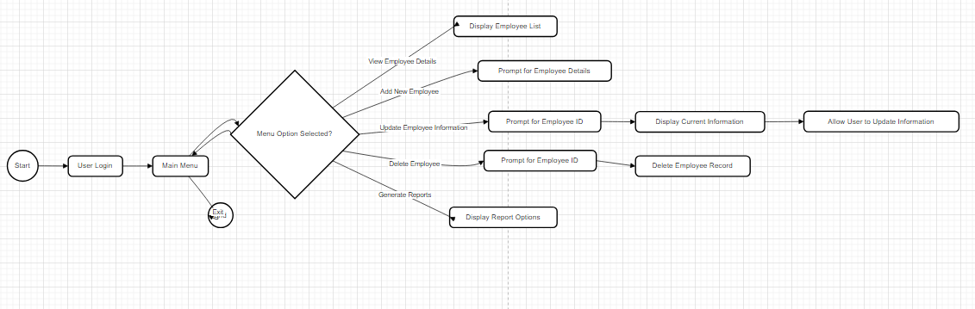

*Figure 06: flowchart*

Explanation:

The flowchart starts with the "Start" node, indicating the beginning of the process. The flow then moves to the "User Login" node, where the user is prompted to enter their login credentials.

From there, the flow moves to the "Main Menu" node, where the user is presented with different options. These options include "View Employee Details," "Add New Employee," "Update Employee Information," "Delete Employee," "Generate Reports," and "Exit."

The flow then enters a decision point denoted by the "Menu Option Selected?" diamond-shaped node. Depending on the user's selection, the flow moves to different nodes.

If the user selects "View Employee Details," the flow moves to the "Display Employee List" node, where the list of employees is shown.

If the user selects "Add New Employee," the flow moves to the "Prompt for Employee Details" node, where the user is prompted to enter the necessary details for a new employee.

If the user selects "Update Employee Information," the flow moves to the "Prompt for Employee ID" node, where the user is prompted to enter the ID of the employee whose information they want to update. The flow then moves to the "Display Current Information" node, where the current information of the selected employee is displayed. The user is then allowed to update the information in the "Allow User to Update Information" node.

If the user selects "Delete Employee," the flow moves to the "Prompt for Employee ID" node, where the user is prompted to enter the ID of the employee they want to delete. The flow then moves to the "Delete Employee Record" node, where the selected employee's record is deleted.

If the user selects "Generate Reports," the flow moves to the "Display Report Options" node, where different report options are shown.

If the user selects "Exit," the flow moves to the "End" node, indicating the end of the process.

The flowchart allows for looping back to the "Main Menu" node after completing any action, allowing the user to continue using the system until they choose to exit.

This flowchart provides a visual representation of the main steps and decision points in the EMS process, helping to illustrate the flow of activities within the system.

* + 1. USE-CASE.

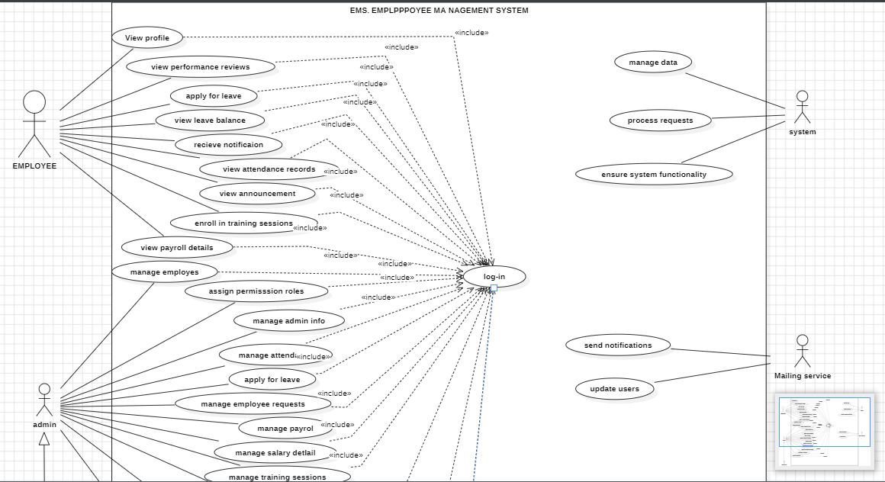

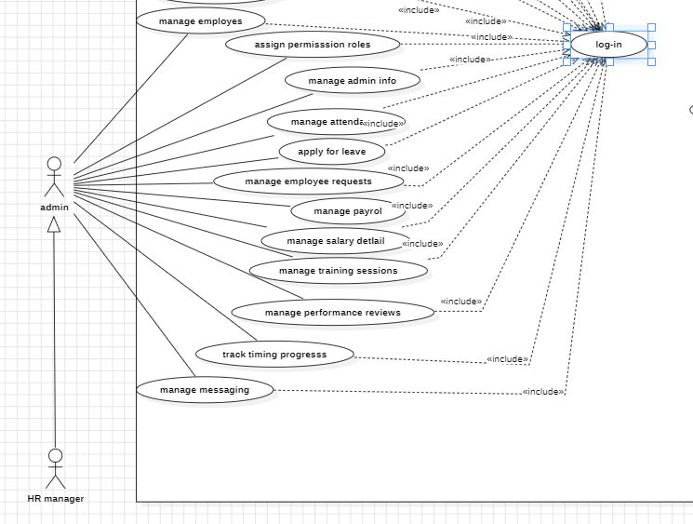

* + 1. Class Diagram.

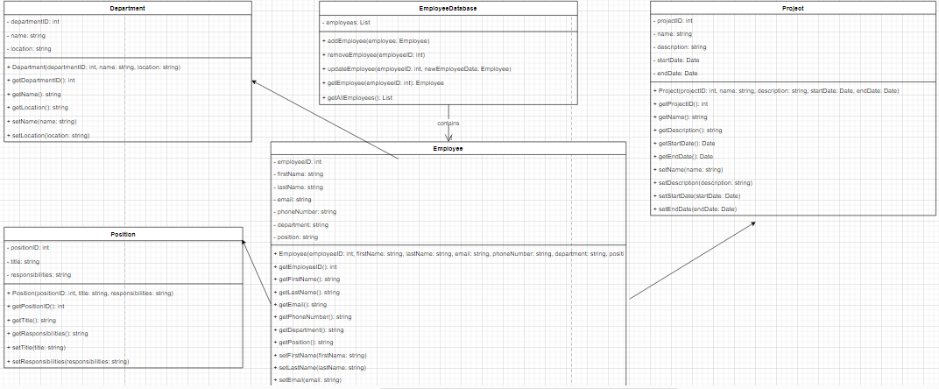

*Figure 08: class Diagram.*

* + 1. **Sequence Diagrams.**

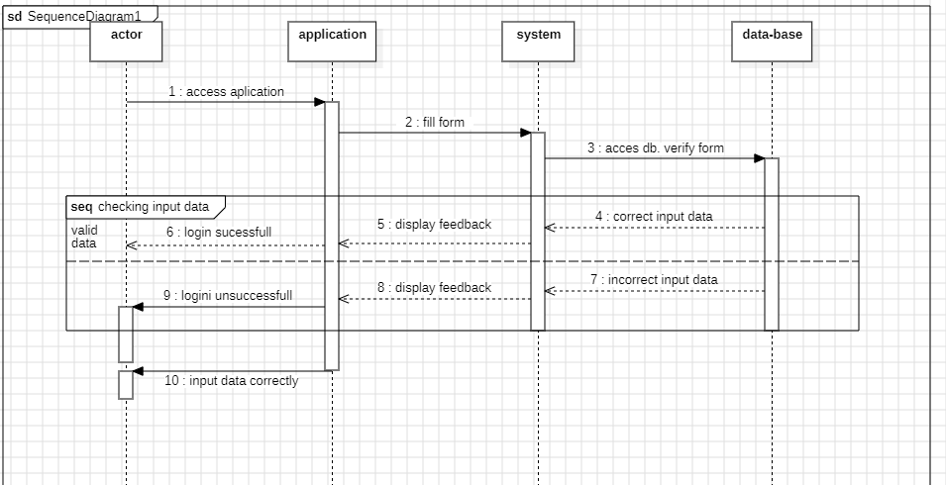

*Figure 09: Login Sequence diagram*

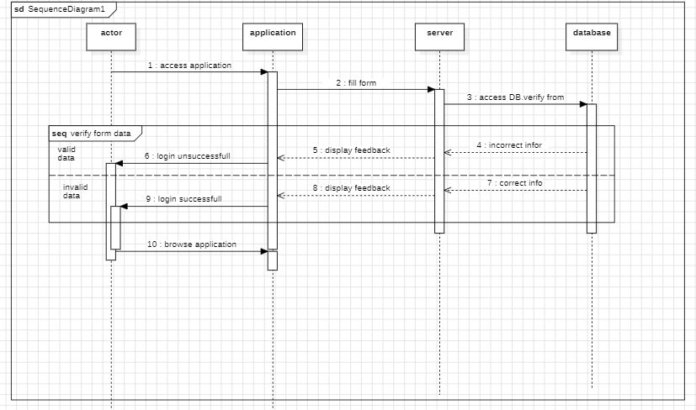

*Figure 10: search info sequence diagram.*

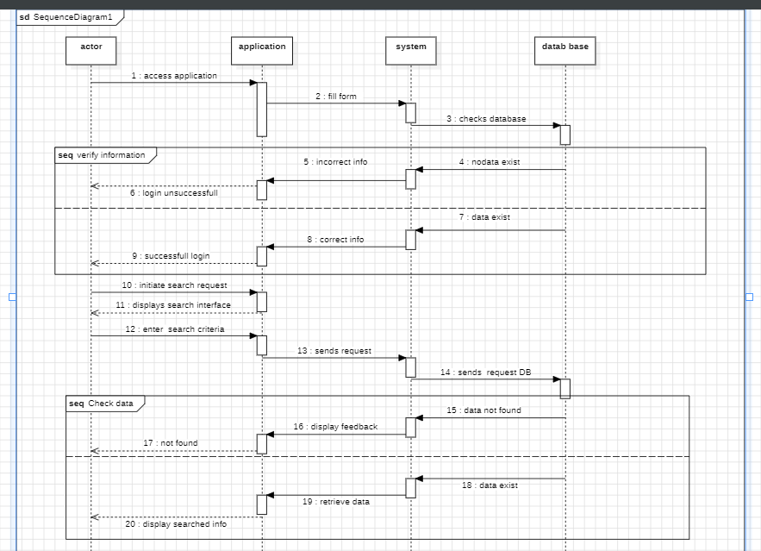

*Figure 11: search info sequence diagram*

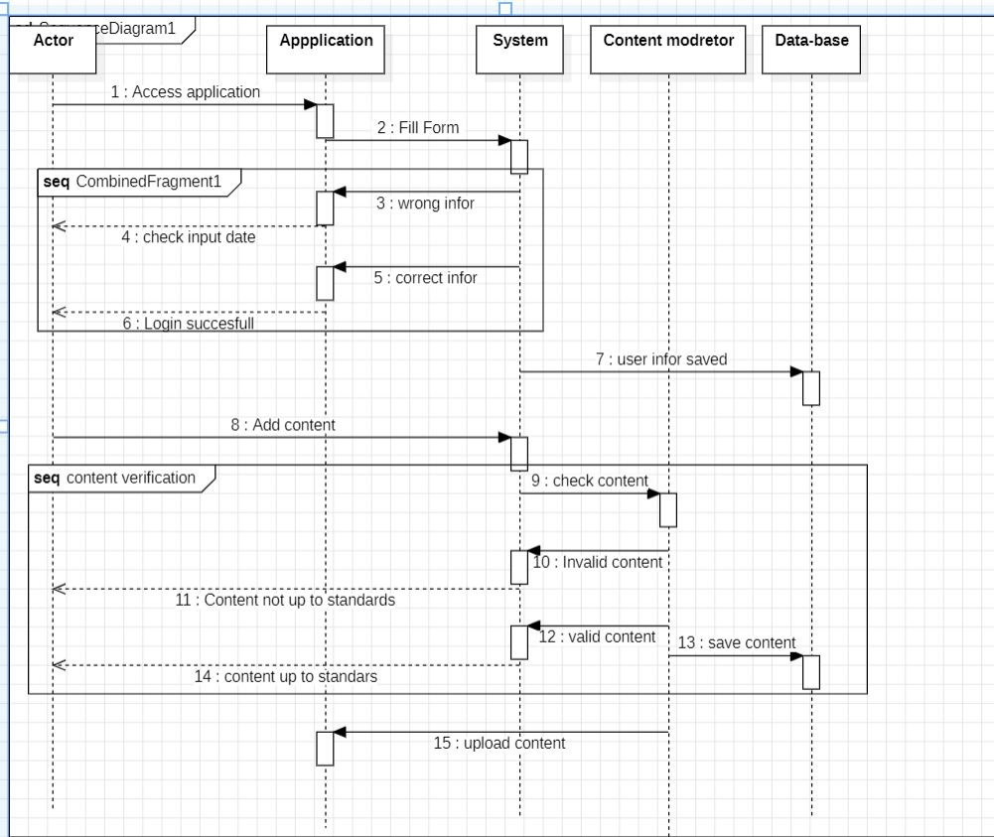

*Figure 11: upload content sequence diagram*

* + 1. **Activity Diagram**

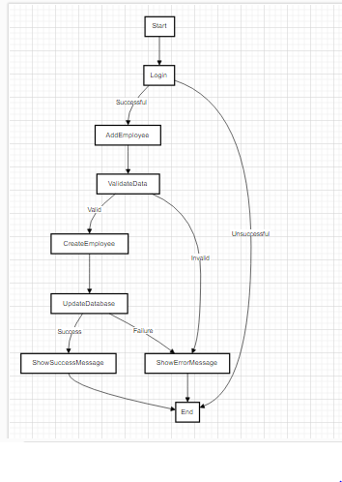

*Figure 12: Activity Diagram*

* **Brief Explanation**
* The process starts with the "Start" node.
* The user is prompted to log in to the EMS system.
* If the login is successful, the process proceeds to the "Add Employee" activity. If the login is unsuccessful, the process ends.
* In the "Add Employee" activity, the user is required to enter the details of the new employee.
* The process then moves to the "Validate Data" activity to validate the entered data.
* If the data is valid (e.g., all required fields are filled correctly), the process continues to the "Create Employee" activity.
* In the "Create Employee" activity, a new employee object is created with the validated data.
* The process then moves to the "Update Database" activity, where the new employee information is stored in the database.
* If the database update is successful, the process proceeds to the "Show Success Message" activity to display a success message indicating that the new employee has been added.
* If the database update fails (e.g., due to a connection issue or an error), the process moves to the "Show Error Message" activity to display an error message.
* Finally, the process ends at the "End" node.

Results/Simulations of working system

*See Figma*

**CHAPTER FIVE**

**APPLICATION AND RELEVANCE OF OUR PROJECT**

The purpose of our employee management system is to help improve workforce productivity, identify ways to engage and retain talents and alleviate administrative burdens for HR professionals

The primary goal of our employee management system is to

Enhance efficiency

Reliability

User satisfaction

**APPLICATION OF OUR SYSTEM**

An application is a way in which a project can be used for a particular purpose

1. Attendance Tracking: our Employee management system Efficiently monitor employee attendance, time-off requests, and leaves.
2. Payroll Management: our employee management system Automate payroll processes, including salary calculations, tax deductions, and direct deposits.
3. Performance Evaluation: our employee management system Streamline performance reviews, goal setting, and feedback collection to enhance
4. HR Administration: Centralize employee data, including personal information, contact details, and employment history for easy access and management.
5. Communication and Collaboration: our employee management system   
   provides a platform for internal communication, task assignment, and collaboration among employees.
6. Compliance Management: our employee management system Ensures adherence to labor laws, regulations, and company policies regarding employee rights, benefits, and safety.

**Relevance of our employee management system**

Our employee management system is relevant for streamlining HR processes, tracking employee data, managing payroll, scheduling shifts, and ensuring compliance with regulations. It enhances efficiency, promotes transparency, and supports strategic decision-making within organizations. Additionally, our employee management system fosters employee engagement by providing tools for performance evaluation, feedback, and professional development opportunities.

**Challenges of our employee management system**

The challenges of our employee management system may include::

1. Data security: Safeguarding employee information from breaches or unauthorized access.
2. Integration: Ensuring compatibility with existing systems and software.
3. User adoption: Overcoming resistance from employees to embrace new processes or technologies.
4. Scalability: Ensuring the system can accommodate growth in the number of employees or organizational complexity.
5. Training and support: Providing adequate training and ongoing support for users to effectively utilize the system.
6. Customization: Tailoring the system to meet the unique needs or workflows of the organization can be complex and costly.
7. ﻿﻿﻿Maintenance: Keeping the system updated with regulatory changes, technology advancements, and organizational requirements.

**Limitations of our employee management system**

1. Dependence on Data Accuracy:  
   Accuracy of data input is crucial for effective functioning. If data is outdated or inaccurate, it can lead to errors in payroll, attendance tracking, and other  
   HR processes.
2. Security Concerns: Employee management systems store sensitive personal and financial information.  
   Without robust security measures, there's a risk of data breaches or unauthorized access.
3. Integration Challenges: Integrating with existing systems like payroll or accounting software can be complex and may require additional resources and customization.
4. User Adoption: Resistance from employees to adapt to new systems or processes can hinder the effectiveness of the management system.
5. Maintenance and Upkeep: Regular updates, maintenance, and

Troubleshooting are necessary to ensure smooth functioning, which can require additional time and resources.